Animated GIFs
Slides 12 and 13: Create an animated company motto or slogan:

Here’s a list of some of the most popular company slogans:

http://www.brighternaming.com/Power_slogans.html

Classwork slogan on Slide 13:
Snap – crackle – pop – Rick Krispies Graphic

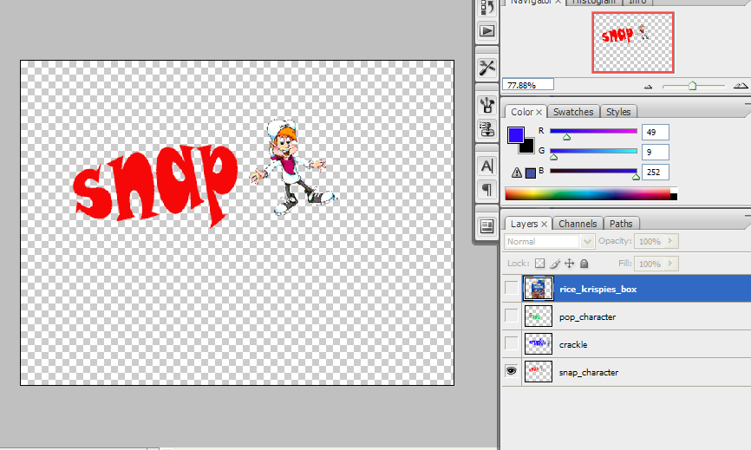

Slide 13: Your create your own animated company slogan using a minimum of 3 layers in Photoshop.

Note:
- Bring the graphics in by using File Menu > Place
- Then click the check mark on the options bar to finalize the placement
- Right click to rastercise the layer
- Merge the picture layer with the appropriate text layer.
- Use Free Transform (Ctrl + T) to rotate the layer.

